DC Brushless Water Pump
- Product Parameter
Model  Character |  |  | HM4510-1 ( Three phase pump)
Working voltage range |  |  | 6VDC-24VDC
Rated power |  |  | 20~60 W
Static water head range |  |  | 1~6 meters
Static flow rate range |  |  | 20~ 50 L/min
Lifespan |  |  | Continuous operation under normal working surrounding＞20000H
Working Environment |  |  | PH value: PH5-10(weak acid and weak base), workable both on land and in water.
Max noise |  |  | Under normal working condition,(1meter over the test instrument)＜40dB
Other optional special functions |  |  | Water shortage protection, over-voltage protection, over-current protection, blocking protection, 0-5V speed control, PWM speed control, FG signal feedback, etc.
Max working temperature |  |  | Under room temperature surroundings, fluid medium temperature≤100℃
Application |  |  | Water circulation oxygenation, swimming pool spa heating system, medical equipment, beauty equipment, mobile bath machine, (solar ) fountain, aquarium, water tank, fish pond, solar water circulation, water circulation of home appliance, crafts, etc.
Color |  |  | Black (Can be customized according to customer`s requirement)
Outlet direction |  |  | Can be adjustable at any angle
Dimension |  |  |  | IP grade | Inlet |  | Outlet |  | Remarks
Length  （mm） | Width（mm） | Height（mm） |  | IP grade | OD（mm） | ID（mm） | OD（mm） | ID（mm） | It has three output
96.5 | 86.0 | -- |  | IP68 | 25.2 | 18.3 | -- | 10.0 | It has three output
- Outside View
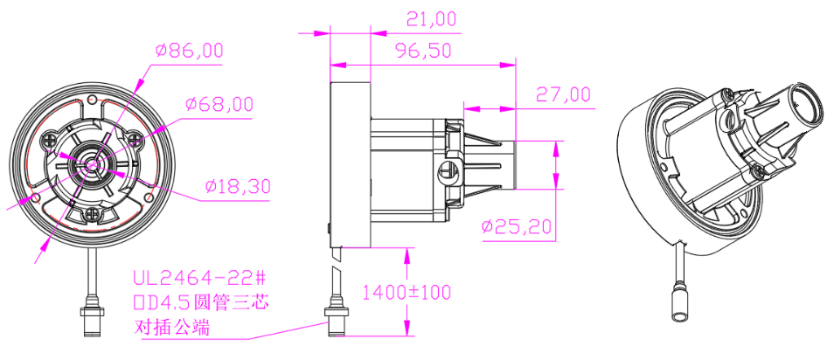
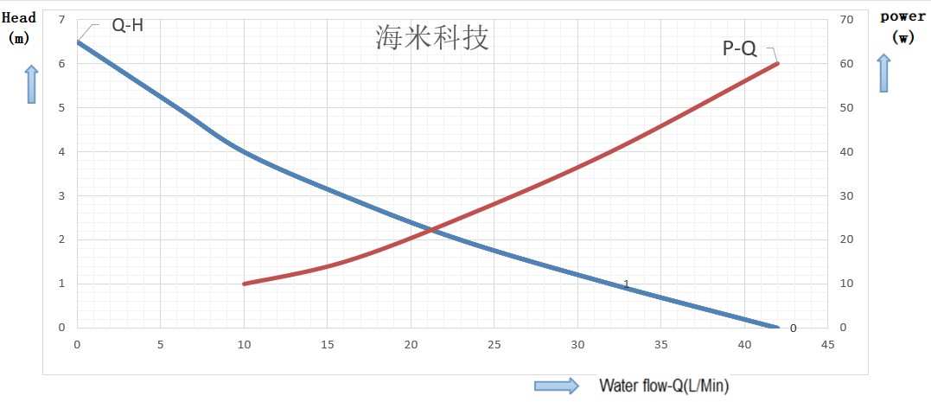
- Curve Graph
Remarks: The graph is just for your reference, the final one comes with the customer required specifications.
- Photo for your reference
